**APPENDIX A**

**To:** Ecobank Ghana Ltd  **Reference No.: EGH/ BNK/ RFQ/JAN/2020/0014**

**Date:** Thursday 16th Jan, 2020 **Supplier Name: AJOMBAPA LINE LIMITED**

We offer to supply on the terms of the Request for Quotation under the above reference dated Friday 10th Jan, 2020("the RFQ") the Goods detailed below.

Any resultant Contract will be subject to the Contract Conditions referred to in the RFQ and such other conditions specified therein.

Delivery of the Goods shall take place within the period stated below from the date of receipt of an award of Contract.

| **Item**  **No.** | **Description of Items** | **Quantity** | **Currency GHS** | |
| --- | --- | --- | --- | --- |
| **Unit Price (VAT & NHIL inclusive)** | **Total Price** |
| **1.** | **PERMANET MARKER** | **480 PCS** | **Gh₵1.50** | **Gh₵720.00** |

|  |  |
| --- | --- |
| **Total Price Primary Trade Packed** | **Gh₵698.4** |
| Less EGH Bank’s Discount (*0%*) | **Gh₵00** |
| Total VAT & NHIL (3%) | **Gh₵21.6** |
| **TOTAL PRICE DELIVERED** | **Gh₵720.00** |

The Delivery period to Ecobank Ghana Ltd from receipt of an award of Contract would be by **30 working days** from receipt of an award of Contract to the Named Destination(s). Delivered to **Ecobank Head Office branch, 2 morocco Lane, off independence Avenue**

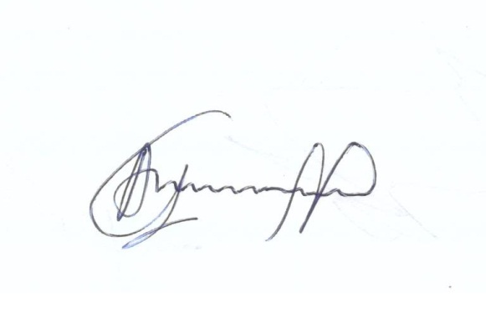This quotation is valid for acceptance for **15 days** from **Thursday 16th Jan, 2020**

Warranty Period: **Six months**

|  |  |  |
| --- | --- | --- |
| .......................................................  **Authorised Signature** | **JOSEPH KOFI AMOABENG**  .......................................................  **Name in Capitals** | **MANAGER**  ...........................................  **Position** |

**Company Name and Address: AJOMBAPA LINE LIMITED, BOX SK 318, SAKUMONO**

**ESTATE, TEMA WEST**

**Company Registration Number: CS089222018**

**Company VAT Number: C0011689129**

**Telephone Number: 0243316159**

**Facsimile Number: NONE**

**E-mail address:** [**ajombapaline@gmail.com**](mailto:ajombapaline@gmail.com) **/ info@ajombapaline.com**

**Web-Site: www.ajombapaline.com**